Playbook Capital
1.INTRODUCTION:
This is an educational website for forex traders or beginners who are interested in trading.

2.OBJECTIVES:
The objective of this website is to provide a:
- To provide a user-friendly website.
- To help people who want to learn how to trade.
- To give people a chance to make money.

3.TARGET AUDIENCE:
With this website I am aiming for people who are 18+ years old.

4.TECHNICAL APTITUTE:
Users are expected to:
1.Have internet and website browsing
2.Filling forms
3.Mobile devices.

5.TYPE OF WEBSITE:
This is an Educational Website.
6.Template Design;
1.Home page
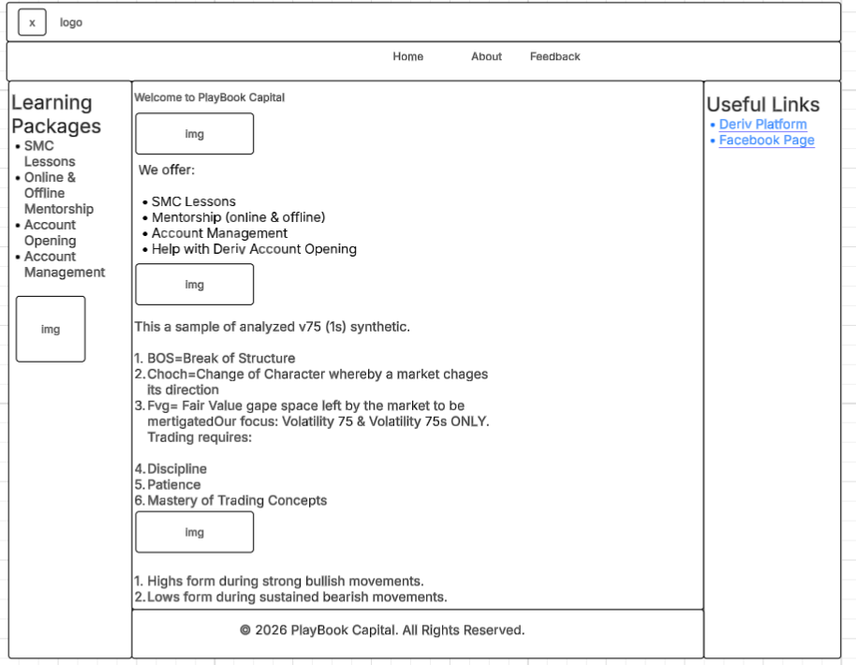

2.About page
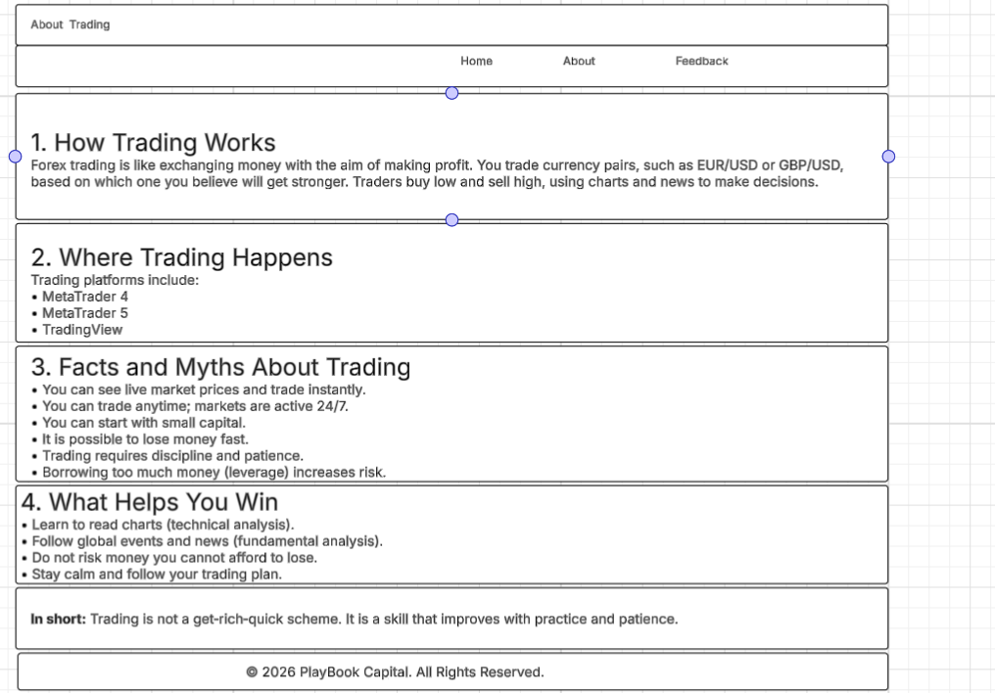
3.Feedback page
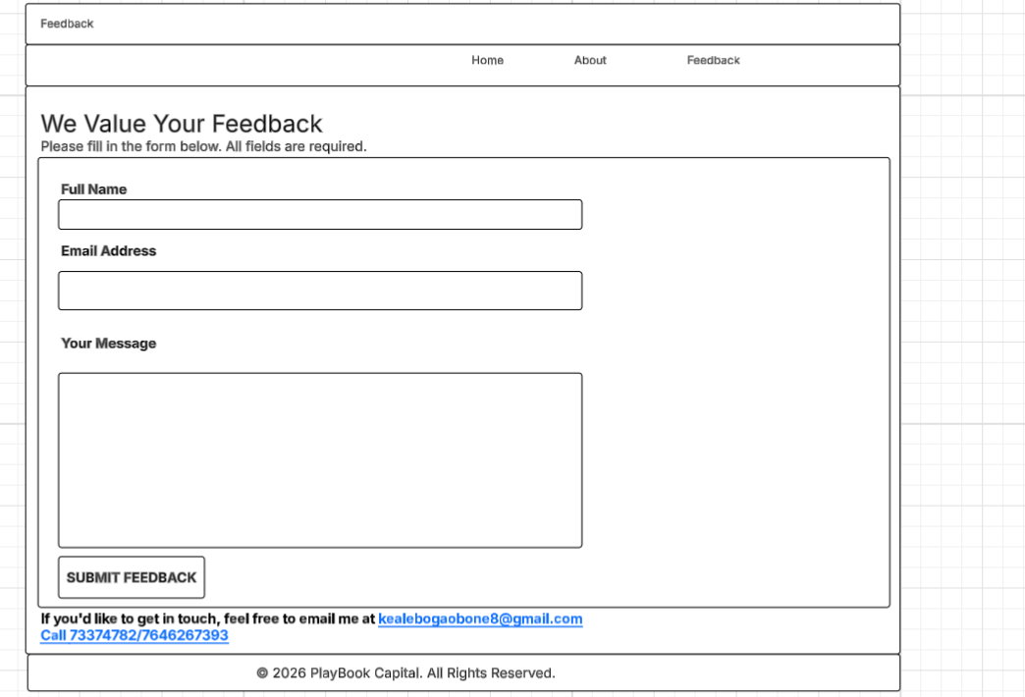

7.Technical Briefing;
1.HTML5
2.CSS3
3.BOOTSTRAP
3.JAVASCRIPT
4.VISUAL STUDIO CODE
5.GITHUB
6.Lucid Chart

Browser Tested on:
1.Google Chrome
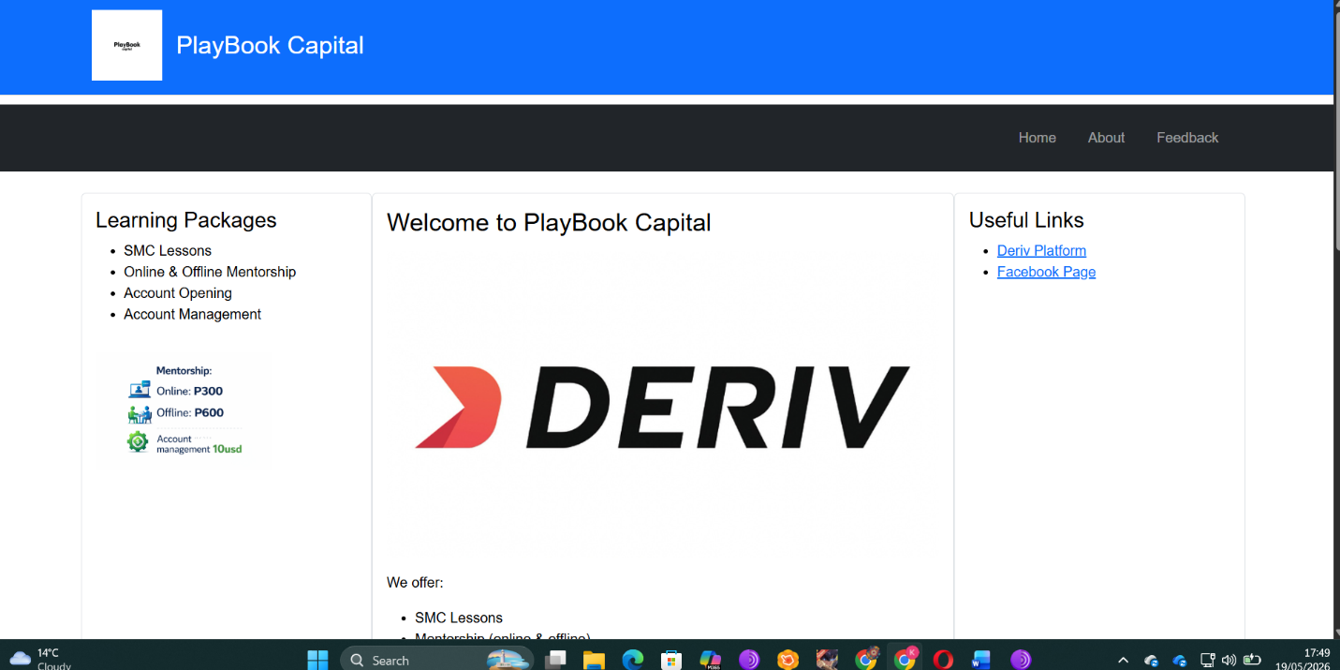
2.Microsoft Edge
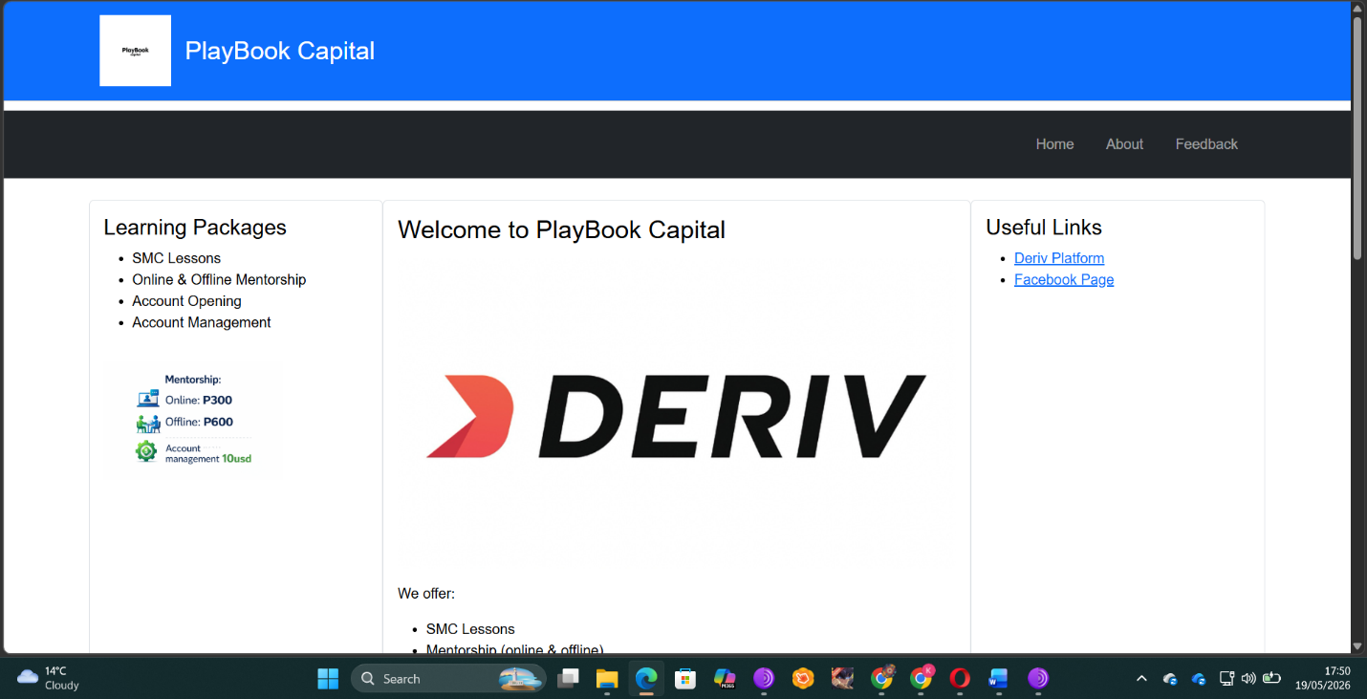

Mobile Tested on:
1.Laptop
2.Adroid phone

8.PUBLISHING
Create a GitHub repository
Upload website files
Use Git commands:
1.git init
2.git add .
3.git commit -m "Initial commit"
4.git push

9.Future Developments
1.Live tutorial videos to be added
2.Tutorial PDFs to be added
3.System to be created for users to be able to pay online

10.Conclusion
This is an educational website created for people above 18 years old who want to learn about trading and who already knows how to trade but still struggling, Playbook Capital will provide them with signals and analyzed charts images to increase their understanding. It contains Technical analyzed pictures of synthetics.

ASSIGNMENT SUBMISSION COVER SHEET
Student Id: CSE25-329
Student names: Kealeboga Obonye
Student email: cse25-329@thuto.bac.ac.bw
Cohort: Group 6
Assignment title: Web Multimedia and Development
Date of submission:
Programme of Study: Computer Systems Engineering
Year of Study: 2025

Intellectual property statement
By checking the box below, I certify that this assignment is my own work and is free from plagiarism. I understand that the assignment may be checked for plagiarism by electronic or other means and may be transferred and stored in a database for the purposes of data-matching to help detect plagiarism. The assignment has not previously been submitted for assessment in any other unit or to any other institution. I have read and understood the Botswana Accountancy College plagiarism guidelines policy.
☐ Agree
Signature; K.Obonye
Date; 19/05/2026

